一、【題目說明】：
參考下圖，以實驗板LED中LD5~LD7顯示第一大道紅綠燈，LD0~LD2顯示第二大道紅綠燈，七段顯示器分別顯示R1與R2的紅燈倒數秒數，按鈕開關BTN0為Reset功能，按下後紅綠燈回復初始狀態。
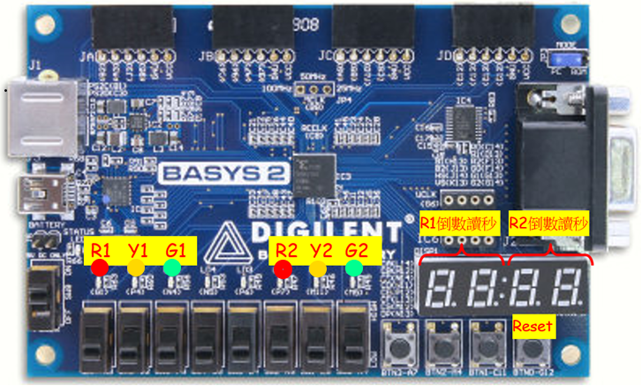
紅綠燈動作原則：
1.開機時的初始狀態為第一大道綠燈、第二大道紅燈
2.在紅燈狀態達13秒時轉為綠燈狀態
3.在綠燈狀態達10秒時轉為黃燈狀態
4.在黃燈狀態達2秒時轉為紅燈狀態
Moore 狀態機之設計：
依動作原則，有6個輸出R1,Y1,G1,R2,Y2,G2分別表式兩個路口的紅燈、黃燈、綠燈，故配以狀態組合：一綠二紅狀態(SG1R2)、一黃二紅狀態(SY1R2)、一紅二紅狀態(SR1R2)、一紅二綠狀態(SR1G2) 、一紅二黃狀態(SR1Y2)。
狀態轉移表：
currentState |  |  | nextState |  |  | 輸出 |  |  |  |  |  | 狀態  說明
C | B | A | C⁺ | B⁺ | A⁺ | R1 | Y1 | G1 | R2 | Y2 | G2 | 狀態  說明
0 | 1 | 0 | 0 | 1 | 1 | 1 | 0 | 0 | 1 | 0 | 0 | SR1R2a
0 | 1 | 1 | 1 | 0 | 0 | 0 | 0 | 1 | 1 | 0 | 0 | SG1R2
1 | 0 | 0 | 1 | 0 | 1 | 0 | 1 | 0 | 1 | 0 | 0 | SY1R2
1 | 0 | 1 | 1 | 1 | 0 | 1 | 0 | 0 | 1 | 0 | 0 | SR1R2b
1 | 1 | 0 | 1 | 1 | 1 | 1 | 0 | 0 | 0 | 0 | 1 | SR1G2
1 | 1 | 1 | 0 | 1 | 0 | 1 | 0 | 0 | 0 | 1 | 0 | SR1Y2

依動作原則需1秒之時脈(clk1sec)及2個4位元計數器(cnt1與cnt2)計算秒數，並以此計數器之值作為狀態機之輸入。

二、【電路設計與描述】：
Verilog code: (詳加註解)：

module s1050689Mid(
input wire mclk,
input wire [0:0] btn,
output wire [0:6] seg,
output wire [3:0] an,
output wire dp,
output [2:0] led1,
output [7:5] led2
);

traffic_light U1(
.clk(mclk),
.reset(btn),
.a_to_g(seg),
.R1_led(led2[7]),
.Y1_led(led2[6]),
.G1_led(led2[5]),
.R2_led(led1[2]),
.Y2_led(led1[1]),
.G2_led(led1[0]),
.an(an),
.dp(dp)
);
endmodule

module traffic_light(
input wire clk,
input wire reset,
output wire R1_led,
output wire Y1_led,
output wire G1_led,
output wire R2_led,
output wire Y2_led,
output wire G2_led,
output wire [6:0] a_to_g ,
output wire [3:0] an ,
output wire dp
);
reg [2:0] currentState,nextState;
reg r1,y1,g1,r2,y2,g2;
assign R1_led = r1 ;
assign Y1_led = y1 ;
assign G1_led = g1 ;
assign R2_led = r2 ;
assign Y2_led = y2 ;
assign G2_led = g2 ;

wire [15:0] x;
reg [15:0] y;
reg flag;
wire [3:0] cnt;
reg [29:0] clkdiv1;
assign cnt= clkdiv1[29:26];
assign x = y;

x7seg Xl (
.x (x),
.clk(clk),
.clr(reset),
.a_to_g(a_to_g),
.an(an),
.dp(dp)
);
always@(currentState or cnt or flag) ///燈的狀態
begin
case(currentState)
3'b011:
if(cnt==4'b1010)
nextState <= 3'b100;
else
nextState <= 3'b011;

3'b100:
if(cnt==4'b1100)
nextState <= 3'b101;
else
nextState <= 3'b100;

3'b101:
if(cnt==4'b1101)
nextState <= 3'b110;
else
nextState <= 3'b101;

3'b110:
if(cnt==4'b1010)
nextState <= 3'b111;
else
nextState <= 3'b110;

3'b111:
if(cnt==4'b1100)
nextState <= 3'b010;
else
nextState <= 3'b111;
3'b010:
if(cnt==4'b1101)
nextState <= 3'b011;
else
nextState <= 3'b010;
default:begin
nextState <= 3'b011 ;
end
endcase
if(flag == 0)

if(cnt>=4'b0100)
y = {8'h0,8'hd-cnt};
else
y = {8'h0,8'h13-cnt};

else
if(cnt>=4'b0100)
y = {8'hd-cnt,8'h0};
else
y = {8'h13-cnt,8'h0};
end

//時脈分頻器(除頻)
always @ (posedge clk or posedge reset)//因為f=50百萬下 調慢50百萬 即可變成每秒1下
begin

if (reset==1)
begin
currentState <= 3'b011 ;
flag <= 0;
end
else currentState <= nextState;

if(reset==1) clkdiv1 <= 0;
else if(cnt==4'b1110)begin
clkdiv1 <= 0;
flag <= ~flag ;
end
else clkdiv1 <= clkdiv1 + 1;
end

always@(currentState)
begin
case(currentState)
3'b010: begin
r1=1'b1;
y1=1'b0;
g1=1'b0;
r2=1'b1;
y2=1'b0;
g2=1'b0;
end

3'b011: begin
r1=1'b0;
y1=1'b0;
g1=1'b1;
r2=1'b1;
y2=1'b0;
g2=1'b0;
end

3'b100: begin
r1=1'b0;
y1=1'b1;
g1=1'b0;
r2=1'b1;
y2=1'b0;
g2=1'b0;
end
3'b101: begin
r1=1'b1;
y1=1'b0;
g1=1'b0;
r2=1'b1;
y2=1'b0;
g2=1'b0;
end
3'b110: begin
r1=1'b1;
y1=1'b0;
g1=1'b0;
r2=1'b0;
y2=1'b0;
g2=1'b1;
end
3'b111: begin
r1=1'b1;
y1=1'b0;
g1=1'b0;
r2=1'b0;
y2=1'b1;
g2=1'b0;
end

default:begin
r1=1'b0;
y1=1'b0;
g1=1'b1;
r2=1'b1;
y2=1'b0;
g2=1'b0;
end
endcase
end

endmodule

module x7seg(
input wire [15:0] x,
input wire clk,
input wire clr,
output reg [6:0] a_to_g,
output reg [3:0] an,
output wire dp
);
wire [1:0] s;

reg [3:0] digit;
wire [3:0] aen;
reg [19:0] clkdiv;
assign dp = 1;

// count every __ ms
assign s= clkdiv[19:18];

// enable all digits
assign aen = 4'b1111;

// Digit select: ancode
always@(*) begin
an =4'b1111;
if (aen[s] ==1) an[s] = 0;
end

//時脈分頻器(除頻)
always @ (posedge clk or posedge clr)
begin
if(clr==1) clkdiv <= 0;
else clkdiv <= clkdiv + 1;
end

always@(*) //4位4選1 : mux44
case (s)
0: digit = x[3:0];
1: digit = x[7:4];
2: digit = x[11:8];
3: digit = x[15:12];
default: digit = x[3:0];
endcase

// 7段解碼器(hex7seg);
always @(*)
case (digit)
0: a_to_g = 7'b0000001;
1: a_to_g = 7'b1001111;
2: a_to_g = 7'b0010010;
3: a_to_g = 7'b0000110;
4: a_to_g = 7'b1001100;
5: a_to_g = 7'b0100100;
6: a_to_g = 7'b0100000;
7: a_to_g = 7'b0001111;
8: a_to_g = 7'b0000000;
9: a_to_g = 7'b0000100;
'ha: a_to_g = 7'b0000010;
'hb: a_to_g = 7'b1100000;
'hc: a_to_g = 7'b0110001;
'hd: a_to_g = 7'b1000010;
'hE: a_to_g = 7'b0110000;
'hF: a_to_g = 7'b0111000;
default: a_to_g =7'b0000001;//0
endcase

endmodule

三、【電路合成與驗證】：
- 從Design Summary視窗觀察Synthesis Report，下拉至Final Report內容，擷取畫面貼於下：

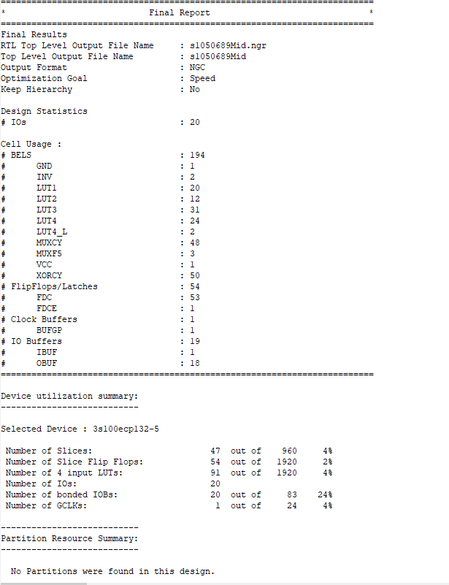

B.從Design Summary視窗觀察Synthesis Report，下拉至Timing Report內容，擷取畫面貼於下：
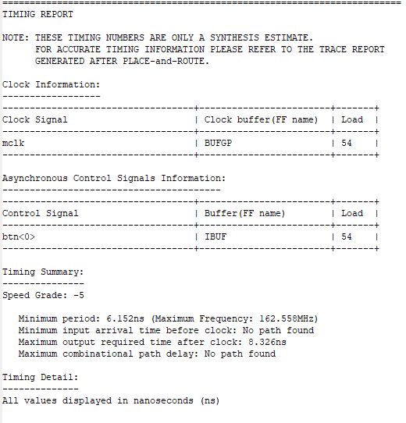

C.實現(Implement)電路後，開啟Design Summary視窗，擷取畫面剪下Project Status、Device Utilization Summary與Performance Summary三個表格。
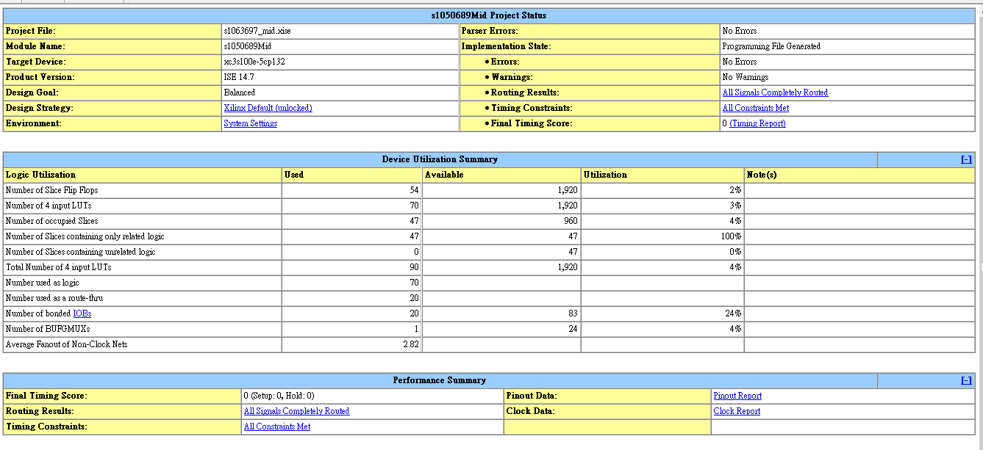

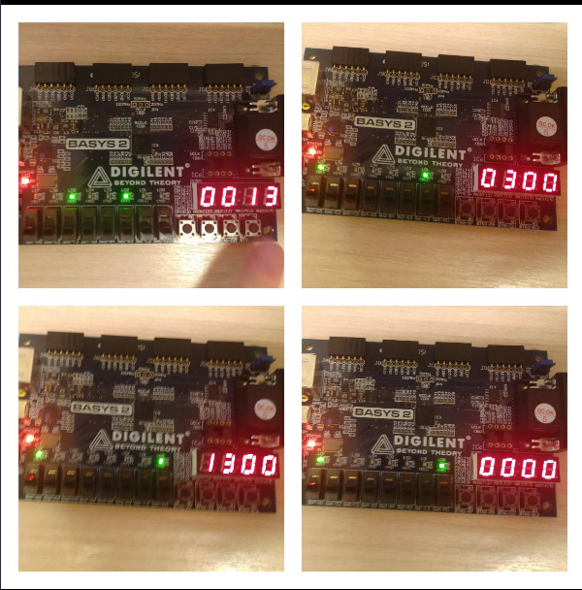
四、Basys2實驗板驗證與結果記錄(操作照片)：

五、說明與心得：
老師的課上到現在大致上都有聽懂，給的資料也很齊全，不過每次做的作業都會差個一兩步才可以成功，都沒辦法修正那些BUG，看來我有某些觀念還沒有融會貫通，得再多仔細看資料了，不過大家一起討論的時候確實能夠突破一些盲點。

六、basys2.ucf(僅列出有使用的，註解部分移除)
NET "mclk" LOC = "B8"; # Bank = 0, Signal name = MCLK
NET "mclk" CLOCK_DEDICATED_ROUTE = FALSE;

NET "seg<0>" LOC = "L14"; # Bank = 1, Signal name = CA
NET "seg<1>" LOC = "H12"; # Bank = 1, Signal name = CB
NET "seg<2>" LOC = "N14"; # Bank = 1, Signal name = CC
NET "seg<3>" LOC = "N11"; # Bank = 2, Signal name = CD
NET "seg<4>" LOC = "P12"; # Bank = 2, Signal name = CE
NET "seg<5>" LOC = "L13"; # Bank = 1, Signal name = CF
NET "seg<6>" LOC = "M12"; # Bank = 1, Signal name = CG
NET "dp" LOC = "N13"; # Bank = 1, Signal name = DP

NET "an<3>" LOC = "K14"; # Bank = 1, Signal name = AN3
NET "an<2>" LOC = "M13"; # Bank = 1, Signal name = AN2
NET "an<1>" LOC = "J12"; # Bank = 1, Signal name = AN1
NET "an<0>" LOC = "F12"; # Bank = 1, Signal name = AN0

NET "led2<7>" LOC = "G1" ; # Bank = 3, Signal name = LD7
NET "led2<6>" LOC = "P4" ; # Bank = 2, Signal name = LD6
NET "led2<5>" LOC = "N4" ; # Bank = 2, Signal name = LD5
NET "led1<2>" LOC = "P7" ; # Bank = 3, Signal name = LD2
NET "led1<1>" LOC = "M11" ; # Bank = 2, Signal name = LD1
NET "led1<0>" LOC = "M5" ; # Bank = 2, Signal name = LD0

NET "btn<0>" LOC = "G12"; # Bank = 0, Signal name = BTN0

